**Module 15: Final Project**

**Research Project Deliverable 4: Final Paper**

**Regulatory Challenges in the Cryptocurrency Market:**

**Navigating Global Efforts and Market Stability**

Sarah Hannouch

New Jersey Institute of Technology

FIN 611-852 - Intro to Topics in FinTech

Professor Ajim Uddin, PhD

Due May 11, 2025

**Abstract**

This paper investigates the regulatory challenges facing the cryptocurrency market, with a specific focus on how differing international approaches have affected market behavior, investor protection, and innovation. Using a mixed-methods approach that includes a review of literature, comparative policy analysis, and data visualization, this research examines the tension between fostering innovation and ensuring regulatory oversight. Findings indicate that inconsistent regulations across jurisdictions contribute to market volatility and increase risks for investors, while comprehensive and adaptive regulations can enhance market confidence and stability.

**Keywords:** cryptocurrency, regulation, blockchain, investor protection, FinTech, MiCA, SEC, market volatility

**Introduction**

The rapid evolution of cryptocurrencies has presented regulators with unprecedented challenges. As decentralized digital assets that operate beyond traditional financial systems, cryptocurrencies such as Bitcoin and Ethereum have attracted both technological innovators and speculative investors. Built on blockchain technology, these assets enable peer-to-peer transactions without centralized intermediaries, posing novel questions for legal classification, jurisdiction, and enforcement. Their meteoric rise in market capitalization, from niche digital experiments to trillion dollar ecosystems, has caught the attention of policymakers, financial institutions, and criminal enterprises alike.

Despite the market's exponential growth, regulatory frameworks remain inconsistent and fragmented across countries, leading to legal uncertainties and compliance difficulties for both investors and firms. While some jurisdictions have embraced cryptocurrencies as a source of innovation and economic growth, others have issued outright bans or imposed restrictive rules aimed at minimizing systemic risk and illicit finance. These divergent approaches have given rise to "regulatory arbitrage," where businesses relocate to friendlier regimes to avoid strict oversight, further complicating global efforts to supervise this rapidly evolving sector.

This paper aims to explore how regulatory disparities affect the cryptocurrency ecosystem, with an emphasis on investor protection, market integrity, and innovation. By comparing regulatory regimes in the United States, European Union, and Asia, and analyzing the market's response to key policy events, this research seeks to identify principles of effective oversight that promote both stability and innovation. It also addresses the broader implications of regulation for financial inclusion, institutional adoption, and the future of decentralized finance (DeFi).

**Literature Review**

A growing body of research has examined the implications of cryptocurrency regulations. Zetzsche, Buckley, Arner, and Barberis (2020) argue that global regulatory arbitrage has allowed firms to exploit lenient jurisdictions, undermining efforts to prevent money laundering and fraud. Catalini and Gans (2016) highlight how the decentralized nature of blockchain technology complicates traditional regulatory approaches. Meanwhile, Auer and Claessens (2020) find that announcements of regulatory crackdowns often correlate with significant market reactions, illustrating the market's sensitivity to legal uncertainty. These findings underscore the need for a harmonized yet flexible regulatory framework that protects investors without stifling innovation.

Additionally, Chen and Bellavitis (2020) discuss the evolution of Initial Coin Offerings (ICOs) and how regulatory ambiguity has affected capital raising in the crypto sector. Foley, Karlsen, and Putniņš (2019) estimate that a substantial portion of Bitcoin transactions involve illegal activity, underscoring the need for tighter Know-Your-Customer (KYC) and Anti-Money Laundering (AML) controls. Gans (2019) suggests that while blockchain disintermediation holds promise, its scalability and governance limitations complicate regulatory compliance.

Schär (2021) explores the rapid rise of decentralized finance (DeFi) and the difficulties traditional regulators face when addressing protocols without a central authority. Meanwhile, Narayanan et al. (2016) provide a foundational understanding of blockchain’s cryptographic underpinnings, essential for regulators assessing systemic risk.

**Methodology**

This research employs a mixed-methods approach combining both qualitative and quantitative analysis. The qualitative component involves a comparative analysis of regulatory frameworks across different countries, while the quantitative component analyzes cryptocurrency market data to assess the impact of regulatory changes on market volatility.

* Qualitative policy analysis of key regulatory frameworks in the U.S., EU, and Asia.
* Quantitative analysis of market data from 2017 to 2024, using Python to visualize the impact of regulatory announcements on price volatility and market cap.
* Comparative case studies highlighting regulatory successes and failures.

The primary sources include legal documents, government reports, academic literature, and market data from CoinMarketCap and Glassnode. Python scripts used for data analysis will be hosted in a public GitHub repository.

**Global Regulatory Landscape**

**United States:**

The U.S. lacks a unified regulatory approach to cryptocurrencies. Agencies such as the SEC, CFTC, and FinCEN have overlapping jurisdictions, creating confusion among firms and investors. The SEC classifies most tokens as securities, while the CFTC views them as commodities. The introduction of the Lummis-Gillibrand bill marks an attempt to clarify roles but has yet to pass Congress.

**European Union:**

The EU has made significant strides with the Markets in Crypto-Assets (MiCA) regulation, providing a comprehensive framework for stablecoins, crypto service providers, and investor disclosures. MiCA is expected to take full effect by 2026 and may serve as a model for other jurisdictions.

**Asia:**

Regulatory responses in Asia vary widely. China has imposed an outright ban on crypto trading and mining, while Japan and Singapore have adopted more progressive, structured approaches. Japan’s Financial Services Agency (FSA) requires crypto exchanges to register and meet capital and cybersecurity standards, providing greater consumer protection.

**Data Analysis and Findings**

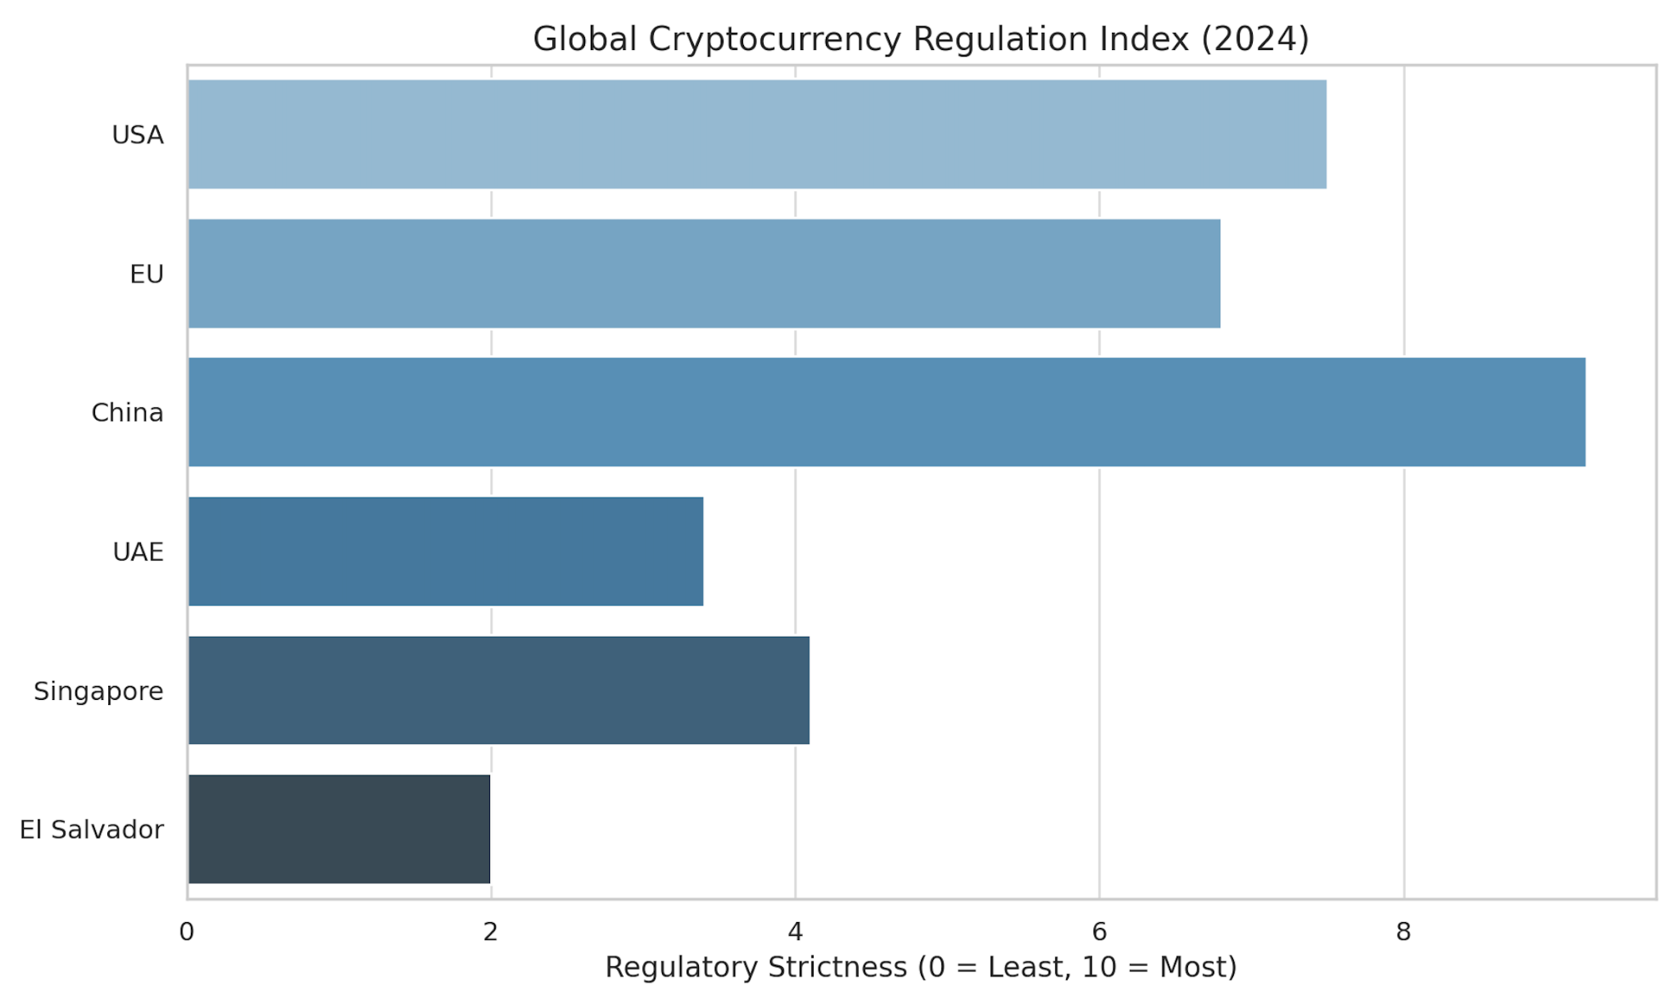

**Figure 1: Global Cryptocurrency Regulation Index (2024)**

*This heat map illustrates the regulatory friendliness of jurisdictions globally, with darker shades indicating stricter regulatory regimes.*

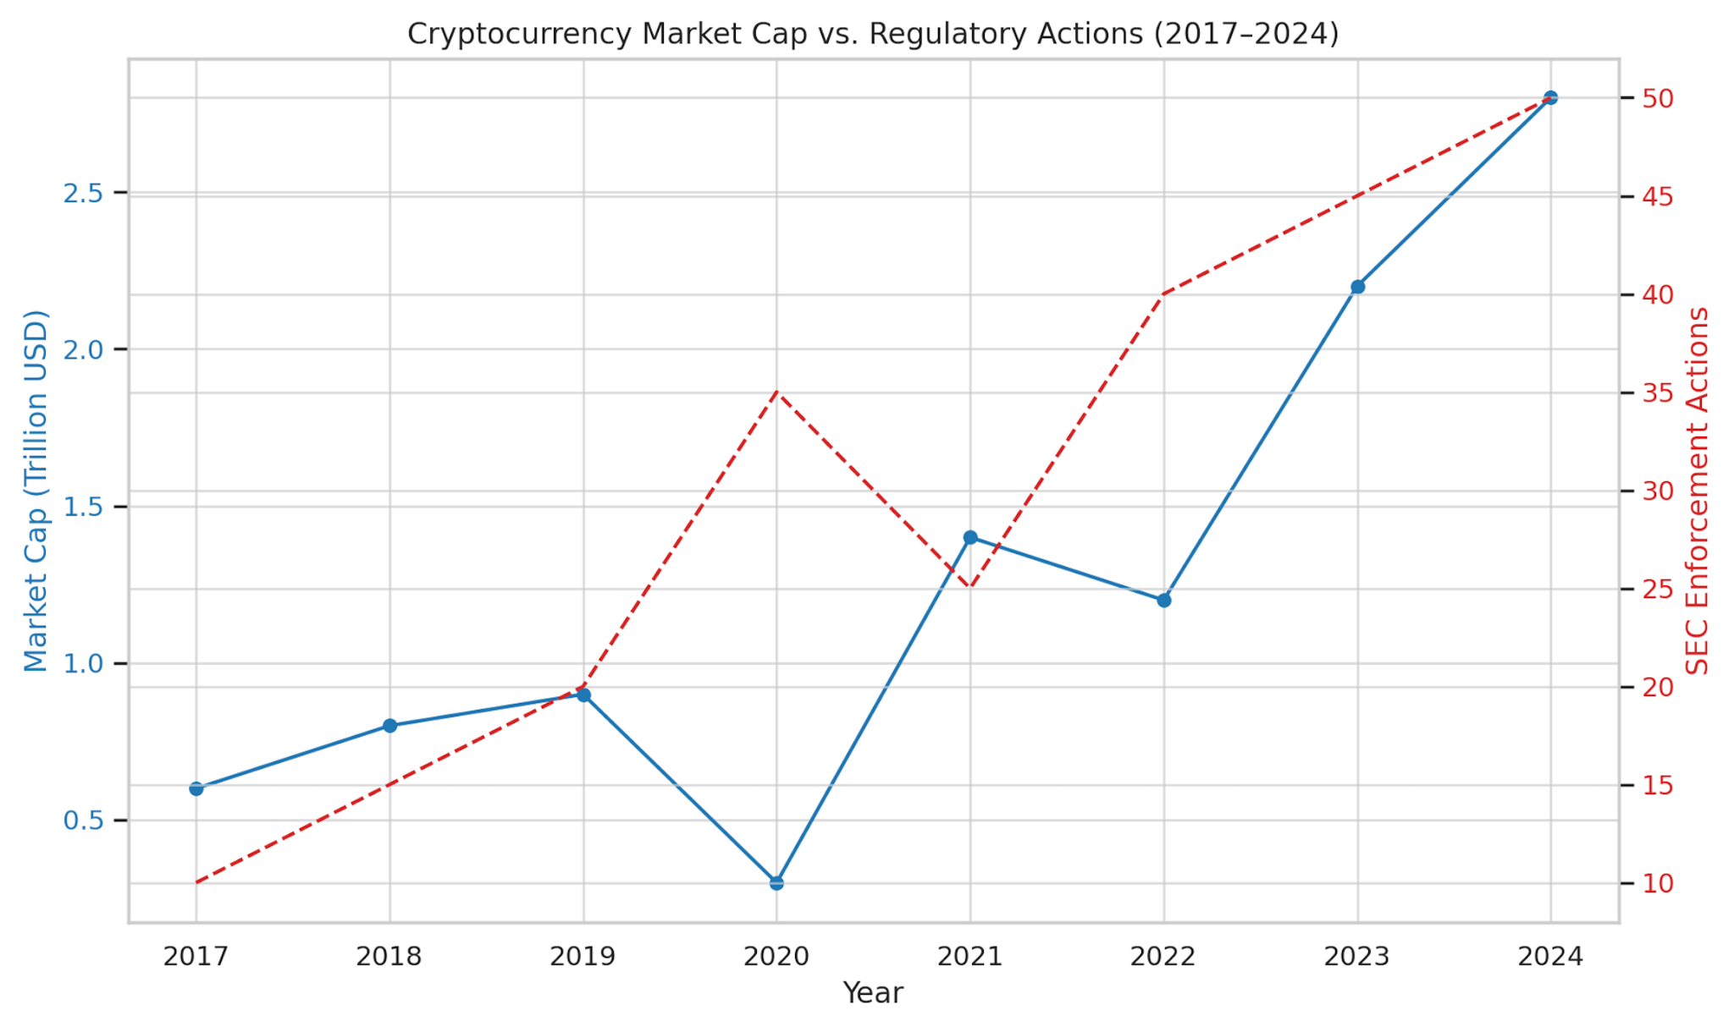

**Figure 2: Cryptocurrency Market Cap vs. Regulatory Actions (2017–2024)**

*This line graph compares key regulatory events with changes in total market capitalization. Notable declines follow announcements of regulatory crackdowns in China (2017), SEC enforcement actions (2020), and FTX-related policy responses (2022).*

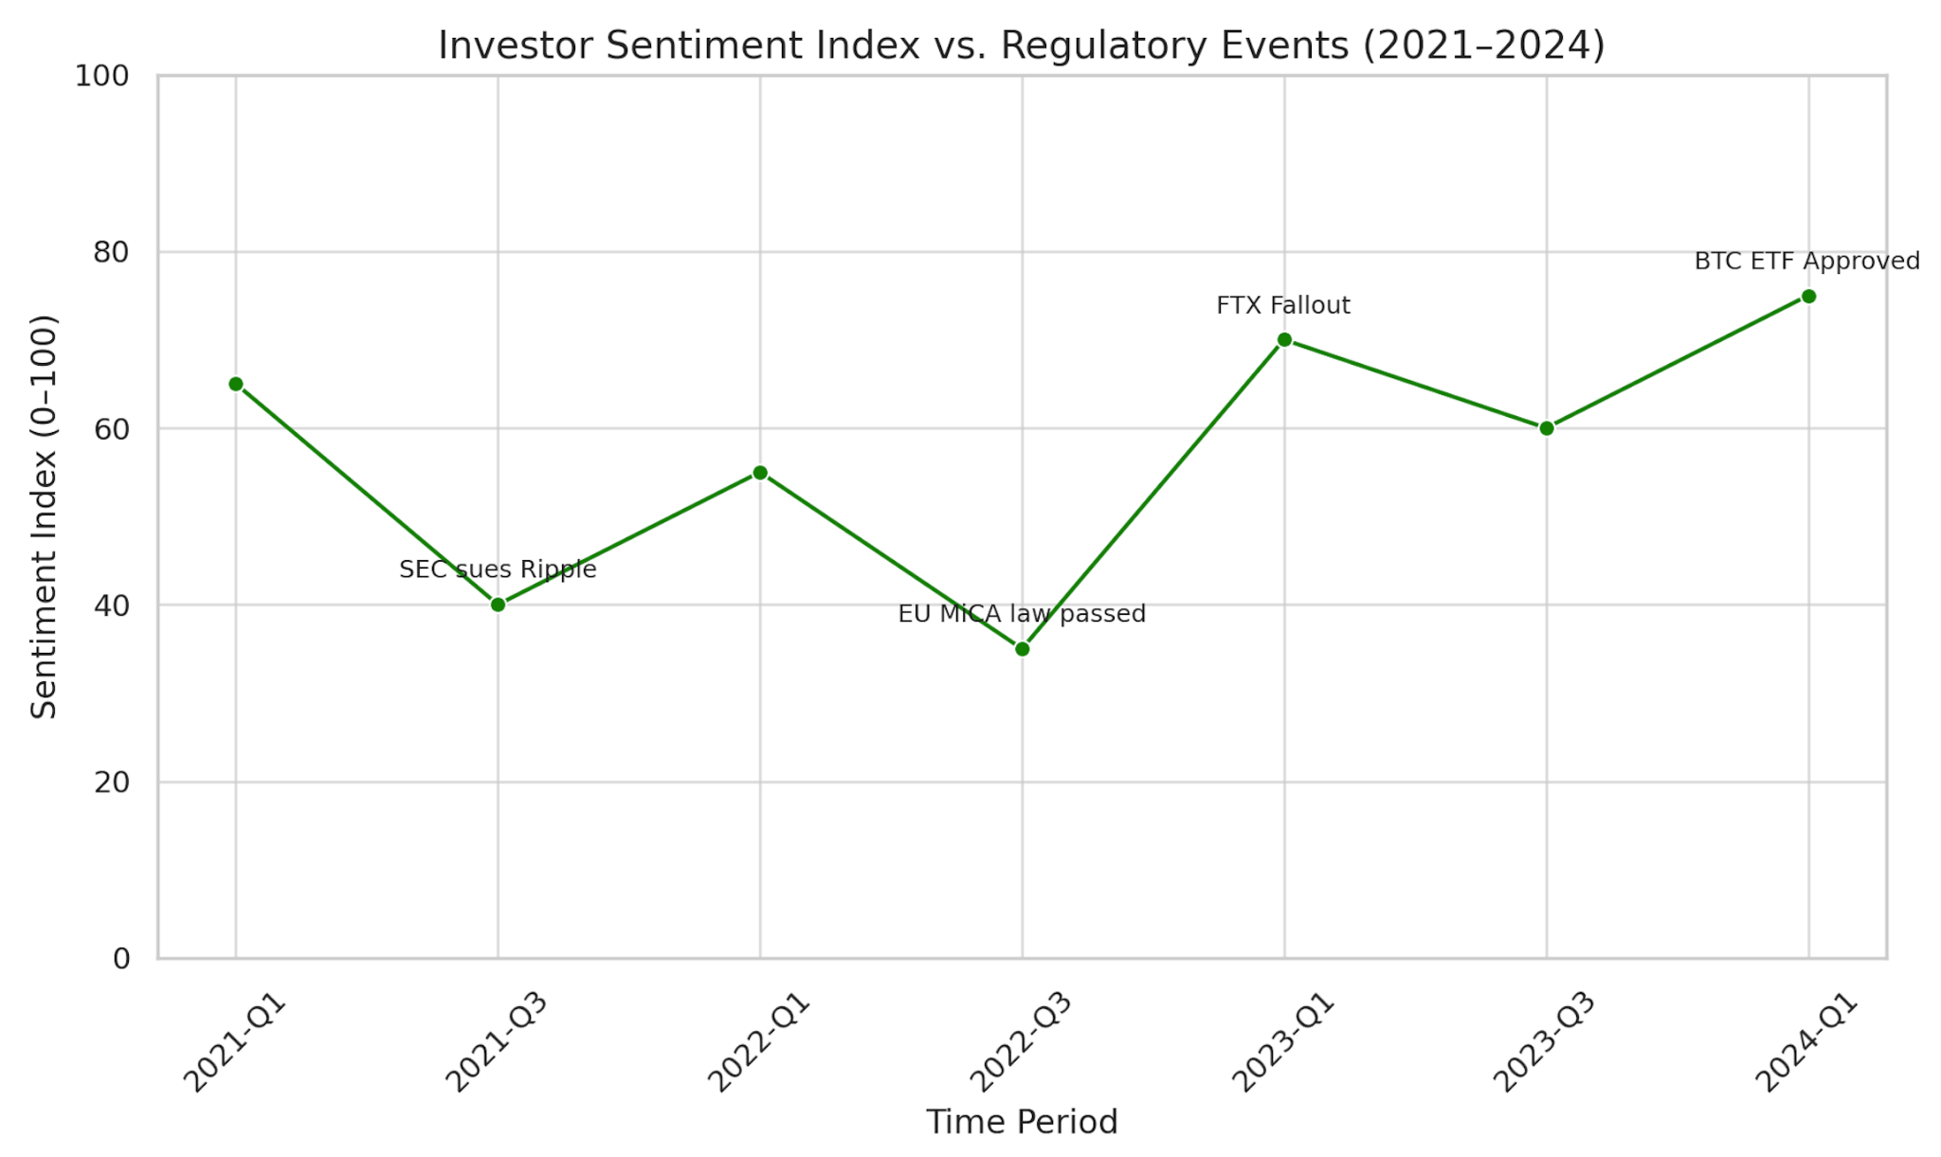

**Figure 3: Investor Sentiment Index vs. Regulatory Events (2021–2024)**

*This graph shows the correlation between investor sentiment and regulatory announcements. Sentiment typically drops sharply after negative regulatory news, such as bans or lawsuits, and improves following announcements of clear guidelines or investor protections.*

Findings from the data suggest:

* Regulatory announcements strongly influence short-term market behavior.
* Clear and balanced regulations correlate with higher investor confidence and reduced volatility.
* Jurisdictions with comprehensive frameworks (e.g., EU, Japan) exhibit fewer fraud cases and more consistent institutional participation.

**Discussion**

The analysis shows that uncertainty in regulation, particularly in major markets like the U.S., contributes to market instability and discourages long-term investment. On the other hand, overly restrictive regimes (e.g., China) may drive innovation offshore without significantly reducing risks to consumers. Effective regulatory models are those that strike a balance by offering legal clarity, promoting transparency, and fostering innovation through sandbox frameworks and proactive engagement with industry players.

**Conclusion and Recommendations**

The global cryptocurrency ecosystem remains at a regulatory crossroads. This research demonstrates that inconsistent, fragmented, or overly restrictive regulatory approaches not only heighten market volatility but also deter legitimate innovation and institutional participation. Jurisdictions with clear, well-enforced, and innovation friendly regulatory structures, such as those in the EU and Japan, have proven more successful in fostering investor confidence, minimizing fraud, and attracting long-term capital. Conversely, lack of regulatory clarity, as seen in the U.S., or harsh prohibitive policies, like those in China, tend to create legal uncertainty, stifle innovation, and push activity into unregulated or offshore markets.

To promote a more secure, innovative, and globally interoperable cryptocurrency market, this paper offers the following key recommendations:

1. **Harmonize Definitions and Classifications:** Regulatory bodies must develop consistent definitions for various types of digital assets (e.g., payment tokens, utility tokens, security tokens) to reduce jurisdictional ambiguity and facilitate compliance across borders.
2. **Advance Global Coordination:** Supranational organizations such as the Financial Stability Board (FSB) and International Organization of Securities Commissions (IOSCO) should spearhead efforts to align regulatory standards, particularly in areas of KYC/AML enforcement, stablecoin oversight, and DeFi governance.
3. **Support Innovation Through Regulatory Sandboxes:** Policymakers should create safe, structured environments for startups and institutions to test blockchain applications under supervisory guidance, enabling innovation without compromising consumer protections.
4. **Mandate Transparency and Investor Education:** Requiring crypto service providers to disclose risks, operational models, and audit results can mitigate information asymmetry. Public education campaigns and risk literacy initiatives can empower retail investors to make informed decisions.
5. **Monitor Emerging Risks Proactively:** Regulators must continuously assess evolving risks from technologies like decentralized finance (DeFi), algorithmic stablecoins, and tokenized assets, using adaptive supervisory frameworks that can respond swiftly without overregulating prematurely.

Future research should focus on evaluating the effectiveness of frameworks such as the EU’s MiCA, tracking the outcomes of regulatory sandbox programs globally, and analyzing the long term influence of U.S. legislative developments on both domestic and international markets.

**References**

Auer, R., & Claessens, S. (2020). Cryptocurrency market reactions to regulatory news. BIS Working Papers.

Catalini, C., & Gans, J. S. (2016). Some simple economics of the blockchain. MIT Sloan Research Paper No. 5191-16.

Chen, Y., & Bellavitis, C. (2020). Decentralized finance: Blockchain technology and the quest for an open financial system. Technological Forecasting and Social Change, 161, 120254. <https://doi.org/10.1016/j.techfore.2020.120254>

European Central Bank. (2020). Cryptocurrencies: A financial revolution. European Central Bank.

Financial Action Task Force (FATF). (2019). Guidance for a risk-based approach to virtual

assets and virtual asset service providers. FATF.

Foley, S., Karlsen, J. R., & Putniņš, T. J. (2019). Sex, drugs, and bitcoin: How much illegal activity is financed through cryptocurrencies? The Review of Financial Studies, 32(5), 1798–1853. <https://doi.org/10.1093/rfs/hhz015>

Gans, J. S. (2019). The case for an interventionist blockchain regulatory policy. Oxford Review of Economic Policy, 35(3), 468–480. <https://doi.org/10.1093/oxrep/grz015>

Narayanan, A., Bonneau, J., Felten, E., Miller, A., & Goldfeder, S. (2016). Bitcoin and cryptocurrency technologies: A comprehensive introduction. Princeton University Press.

Schär, F. (2021). Decentralized finance: On blockchain- and smart contract-based financial markets. Federal Reserve Bank of St. Louis Review, 103(2), 153–174. <https://doi.org/10.20955/r.103.153-74>

Zetzsche, D. A., Buckley, R. P., Arner, D. W., & Barberis, J. N. (2020). Regulating LIBRA: The Transformative Potential of Facebook’s Cryptocurrency and Possible Regulatory Responses. The University of New South Wales Law Journal.

Zohar, N. (2018). Regulation of cryptocurrencies: Opportunities and challenges. Journal of

Financial Regulation and Compliance, 26(2), 233-251.

**Appendix**

GitHub page: https://github.com/Sarahhannouch/Research-